Small intestine microflora at psoriasis.

Its possible role in pathogenesis.

Mikhail Peslyak¹, Natalia Gumayunova², Alex Nesterov², Natalia Potaturkina-Nesterova²,

¹Kudits, Moscow, Russia (presenting),

²Ulyanovsk State University, Ulyanovsk, Russia

Theses:

For the first time researches of transient microflora of proximal small intestine at 121 psoriatics (PASI >=20) are conducted. Сontrol group consists from 43 healthy persons.

Level SIBO more than 10⁵ CFU/ml (TBC > 5) was found at 95 (78,5%) psoriatics.

TBC (total bacterial count) for psoriatics has made average 3х10⁶ CFU/ml that is much more than in the control group - 1,1х10³ CFU/ml.

The correlation between SIBO level and PASI (correlation coefficient R=0,46), between SIBO level and duration of psoriasis disease (R=0,43) has been found.

At 93% of psoriatics Bifidobacterium spp. was found - on average 2х10⁵ CFU/ml (in the control group at 40%, on average 250 CFU/ml).

At 84% of psoriatics Lactobacillus spp. was found, on average 4,6х10⁴ CFU/ml; (in the control group at 19%, on average 350 CFU/ml).

At 79 from 121 (65%) of psoriatics Enterococcus spp. was found - on average 2х10⁵ CFU/ml.

In the control group Enterococcus spp. not found at all.

At part of psoriatics Str.pyogenes (9%) and Str.viridans (30%) were found (in the control group not found).

It is supposed that increased colonization of small intestine by Str.pyogenes and others Gram+ bacteria with similar peptidoglycan interpeptide bridges (in particular E.faecalis and Str.viridans), and also by Gram(-) bacteria can play important role in psoriasis pathogenesis.

The fragments of bacterial products of these bacteria contain PAMP (LPS and specific PG).

These fragments get to systemic blood flow, form chronically increased PAMP-level and chronically increased PAMP-load on blood phagocytes.

It provides systemic psoriatic process functioning.

(Box 1)

For the first time researches of transient microflora of proximal small intestine at 121 psoriatic patients are conducted. PASI of each patient equal to 20 or more.
There are 52 patients with moderate psoriasis (PASI in range from 20 to 30) and 69 patients with severe psoriasis (PASI more than 30).

At all patients psoriasis was in progressing stage.
Control group consists of 43 healthy persons.
For definition of species and subspecies of bacteria method of bacteriological cultures on special mediums was used.

Materials for culturing are received by capture of aspirate during intestinoscopy.

(Box 2) SIBO severity level (121 psoriatic patients)

Level SIBO (small intestinal bacterial overgrowth) more than 10⁵ CFU/ml (TBC > 5) was found at 95 psoriatic patients (78,5%).

No SIBO TBC less than 10⁵ CFU/ml.
SIBO I. No anaerobic. Normal aerobic TBC from 10⁵ to 10⁶ CFU/ml.
SIBO II. Occurrence of anaerobic. TBC from 10⁶ to 10⁷ CFU/ml.
SIBO III. Prevalence of anaerobic. TBC more than 10⁷ CFU/ml.

TBC is total bacterial count.
CFU is colony-forming unit.

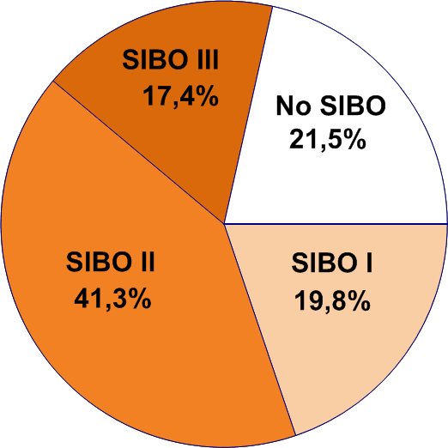
This diagram is based on (Gumayunova 2009a).

(Box 3) Transient microflora of proximal small intestine

TBC for psoriatic patients has made - on average is 3x10⁶ CFU/ml. lg=6,49.

That is much more than in the control group, where is on average is 1,1x10³ CFU/ml. lg=3,05.

The correlation between SIBO level and PASI has been found. r = 0,46.

The correlation between SIBO level and duration of psoriasis disease has been found.
r = 0,43.

At 93% of psoriatic patients Bifidobacterium species was found - on average 2x10⁵ CFU/ml.
lg=5,3.

In the control group at 40%, on average 250 CFU/ml. lg=2,41.

At 84% of psoriatic patients Lactobacillus species was found - on average 4,6x10⁴ CFU/ml. lg=4,66.

In the control group at 19%, on average 350 CFU/ml. lg=2,54.

At 79 of 121 psoriatic patients (65%) Enterococcus species was found - on average 2x10⁵ CFU/ml.
lg =5,28.
They are not found in the control group at all.
At part of psoriatic patients Streptococcus pyogenes (9%) and Streptococcus viridans (30%) were found.
They are not found in the control group at all.

It is necessary to notice that transient microflora was investigated.
Therefore it is only possible to make an indirect conclusion on the condition of parietal microflora. This is the absence of significant colonies of particular species in transient microflora most likely means the absence of its significant colonies also in parietal one.
And, on the contrary, detection of significant colonies of particular species in transient microflora means the probability of presence of its significant colonies also as a part of the parietal.
But absolute value (CFU/ml) may differ essentially.

 | Psoriatics (121 pers.) |  |  | Control healthy (43 pers.)
Microflora | carrier | % of carrier | lg CFU/ml | carrier | % of carrier | lg CFU/ml
Bifidobacterium species | 112 | 93% | 5,3 | 17 | 40% | 2,41
Lactobacillus species | 102 | 84% | 4,66 | 8 | 19% | 2,54
Bacteroides species | 20 | 17% | 3,3 | 5 | 12% | 2,86
E.coli typical | 81 | 67% | 5,04 | 11 | 26% | 2,94
E.coli lactose-neg. | 4 | 3% | 3,62 | 0
E.coli hemolytic | 18 | 15% | 3,6 | 0
Enterococcus species  (incl. E.faecalis) | 79 | 65% | 5,28 | 0
Str.viridans | 36 | 30% | 5,74 | 0
S.aureus | 18 | 15% | 3,24 | 0
Str.pyogenes | 11 | 9% | 4,81 | 0
S.epidermidis | 75 | 62% | 5,54 | 17 | 40% | 2,70
Candida | 45 | 37% | 4,76 | 10 | 23% | 2,43
Acinetobacter spp. | 7 | 6% | 3,56 | 4 | 9% | 2,40
Proteus spp. | 24 | 20% | 4,1 | 7 | 16% | 2,14
Clostridium spp. | 24 | 20% | 5,2 | 0
Klebsiella spp. | 17 | 14% | 3,13 | 0
Moraxella spp. | 63 | 52% | 4,45 | 0
Total bacterial count |  |  | 6,49 |  |  | 3,05

This table is based on (Gumayunova 2009a) and published at (Peslyak 2012a, Tabl. 3, p.46).
Main results are published at (Gumayunova 2009b, Gumayunova 2009c) also.

(Box 4) Other basic researches

Many of patients with psoriasis had malabsorption syndrome.
Eugeny Kharkov with co-workers (from 2005 till now).
Krasnoyarsk state medicine university, Krasnoyarsk, Russia.
(Harkov 2005, Harkov 2006, Harkov 2008)

☼
Majority of patients with psoriasis had high blood LPS-level.
Zuhra Garaeva with co-workers (2005-7).
Kazan Medicine Academy, Kazan, Russia.
(Garaeva 2005, Garaeva 2007)

☼
Phagocytes tolerization (reprogramming) and their properties.
Robert Sabat and Kerstin Wolk with co-workers
University Hospital Charité, Berlin, Germany;
(Wolk 2000, Wolk 2005, Wolk 2003)
Jean-Marc Cavaillon with co-workers.
Institut Pasteur, Paris, France.
(Adib-Conquy 2009, Cavaillon 2006, Cavaillon 2008, Fitting 2004)

☼
Systemic model of pathogenesis.
The antigenic role of streptoccocal peptidoglycan outside skin (gut, tonsils, blood flow) and inside psoriatic skin.
Barbara Baker and Lionel Fry (2006-7).
Faculty of Medicine, Imperial College, London, UK.
(Baker 2000, Baker 2006a, Baker 2006b, Fry 2005, Fry 2007a, Fry 2007b)

(Box 5) Peptidoglycan structure and psoriagenic bacteria PsB

Which bacteria in the intestine are supposed to be psoriagenic?

Hypothesis.
PsB are Gram(+) bacteria: Streptococcus pyogenes, Streptococcus agalactiae, E.faecalis, some of VGS (viridans group streptococci), and some of Bifidobacterium species.

All PsB possess PG-Y - peptidoglycan A3alpha containing interpeptide bridges IB-Y.
IB-Y is interpeptide bridge of Streptococcus pyogenes peptidoglycan, that is L-Ala(2-3) and-or L-Ala-L-Ser.
PG-Y must contain IB-Y and can contain others interpeptide bridges also.
Muramyl dipeptide (MDP) is NOD2 ligand.

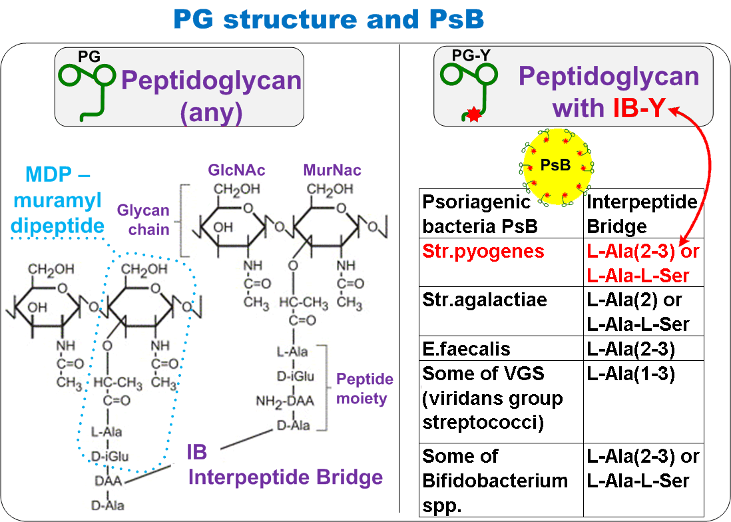
These figure and table are based on (Peslyak 2012a, Table 1, p.14).

(Box 6) Symbols
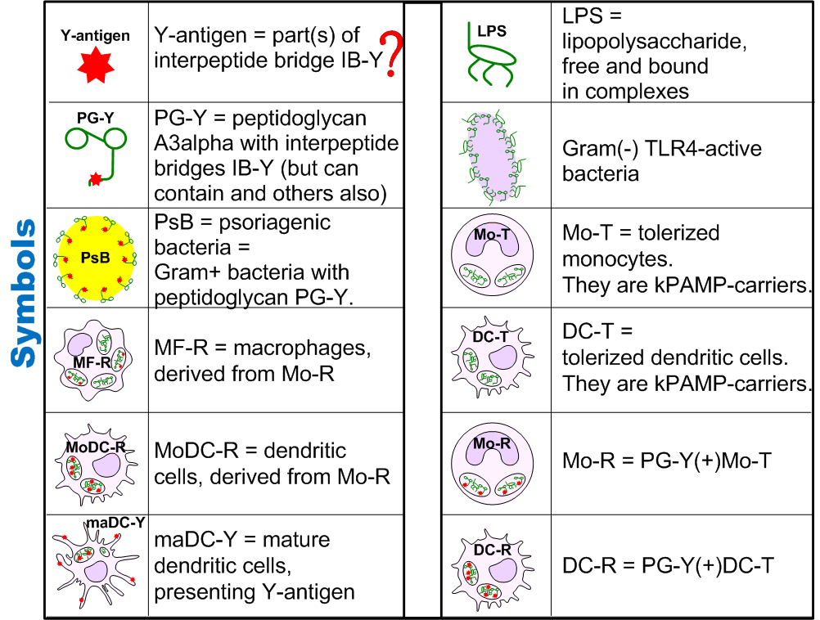

This figure is based on (Peslyak 2012a, Fig.4 and 5, p.61-2).

Which part of cell wall is supposed to be antigenic? What is Y-antigen?

Y-antigen is a part or parts of interpeptide bridge of Streptococcus pyogenes peptidoglycan.
That is Y-antigen is a part or parts of L-Ala(2-3) and-or L-Ala-L-Ser.

Y-antigen is only in those muropeptides which keep characteristic parts of IB-Y, that is L-Ala(2-3) and-or L-Ala-L-Ser, during intracellular degradation of PG-Y.
During processing and presentation of these muropeptides Y-antigen becomes epitope which is distinguished by effector Y-specific T-lymphocytes.
Presence of muramyl dipeptide (MDP), which is NOD2 ligand, in the same phagosomas(endosomes) essentially raises efficiency of PG-Y processing and Y-antigen presentation.
The idea that interpeptide bridges of beta-streptococcus is a psoriasis antigen published for the first time in 2006 by Baker and Fry (Baker 2006a).

(Box 7) Systemic psoriatic process SPP. Short description.

Increased colonization of small intestine by Streptococcus pyogenes and others Gram+ bacteria with similar peptidoglycan (named psoriagenic bacteria PsB) and also by Gram(-) TLR4-active bacteria can play important role in psoriasis pathogenesis.
The fragments of bacterial products contain kPAMP (LPS and PG).
PAMP is a pathogen-associated molecular pattern.

Bacterial products get from small intestine into blood flow independently at absorption of nutrients. It occurs at all healthy people. Income of kPAMP into blood flow becomes more intensive at small intestine hyperpermeability.
In blood flow kPAMP contact, are bound and endocytosed by phagocytes (neutrophils, monocytes and dendritic cells). This influence is named by kPAMP-load.
Increased both kPAMP-level and kPAMP-load on blood phagocytes is named by PAMP-nemia.

Increased kPAMP-load provided growth of fractions of activated monocytes and dendritic cells and fractions of tolerized monocytes Mo-T and tolerized dendritic cells DC-T in blood flow.
One of properties of tolerized Mo-T and DC-T is a slow degradation of endocytosed content.
Thereof tolerized Mo-T and DC-T become kPAMP-carriers.
Some of them occurs (PG-Y)-carriers.
Mo-R is PG-Y(+)Mo-T and DC-R is PG-Y(+)DC-T.
Subprocess SP8.1 is growth of subfractions Mo-R and DC-R with increased (PG-Y)-carriage.

Systemic psoriatic process SPP operates only if SP8.1 operates.

If tolerized Mo-R and DC-R getting into inflamed derma – they can be transformed into mature maDC-Y, presenting Y-antigen.

How Y-antigen is transported from intestine to skin?

From small intestine Y-antigen (inside PG-Y) gets to blood flow by itself.
In blood flow Y-antigen (inside PG-Y) endocytosed by phagocytes.
Y-antigen remains non-degraded for extended time only in tolerized phagocytes.
Y-antigen comes into derma inside tolerized monocytes Mo-R and tolerized dendritic cells DC-R.

Such income is supposed to be the main reason of start and support of psoriatic plaques
as only Mo-R and DC-R can transform into mature dendritic cells maDC-Y,
presenting Y-antigen.

Intensity of Y-antigen income (inside Mo-R and DC-R) from blood flow,
defines severity of psoriatic plaque.

(Box 8) Systemic psoriatic process SPP and some local processes. Illustration.

SPP is based on pathogenesis model suggested by Barbara Baker and Lionel Fry.

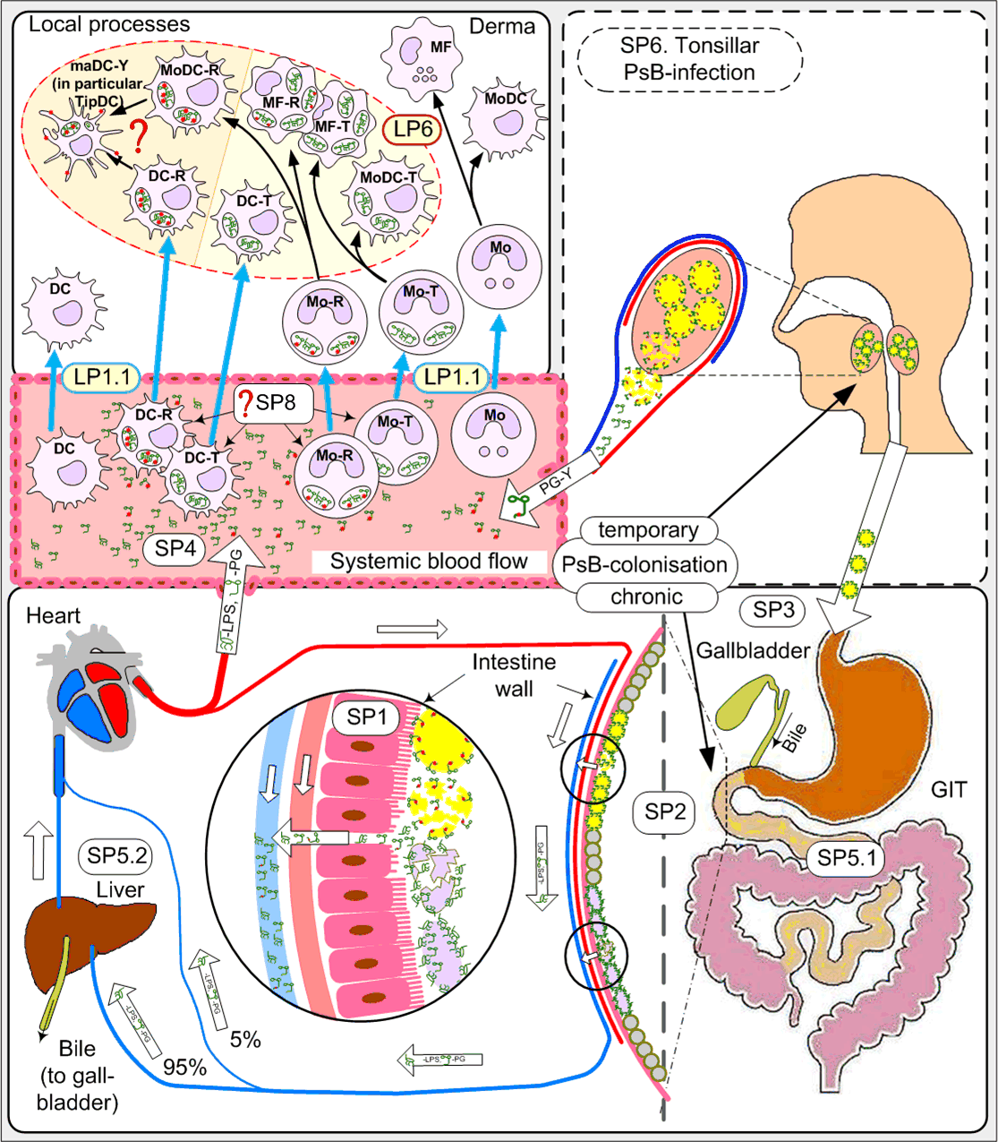

This figure is based on (Peslyak 2012a, fig.6, p.62).

(Box 9) SPP. Main systemic subprocesses.

SP1. Hyperpermeability of intestinal walls for bacterial products; (see Box 4)

SP2. Growth of populations of Gram+ (including psoriagenic PsB) and Gram(-) TLR4-active bacteria; (see Boxes 1-3 and Box 10)

SP3. Disturbance of production and/or circulation of bile acids;

SP4. PAMP-nemia. Increased kPAMP-load on blood phagocytes. Increased kPAMP level in blood. The major kPAMP are PG and LPS.

SP4.1. (PG-Y)-nemia; (see Box 10)

SP5. Overload and/or disorders of detoxication systems in intestine (SP5.1) and hepatobiliary system (SP5.2); (see Box 8)

SP6. Tonsillar PsB-infection; (see Box 8)

SP8. Growth of tolerized fractions Mo-T and DC-T. Increased kPAMP-carriage.
SP8.1. Growth of subfractions Mo-R and DC-R. Increased (PG-Y)-carriage. (see Box 10)

(Box 10) SPP-basis: Tolerization + (PG-Y)-carriage
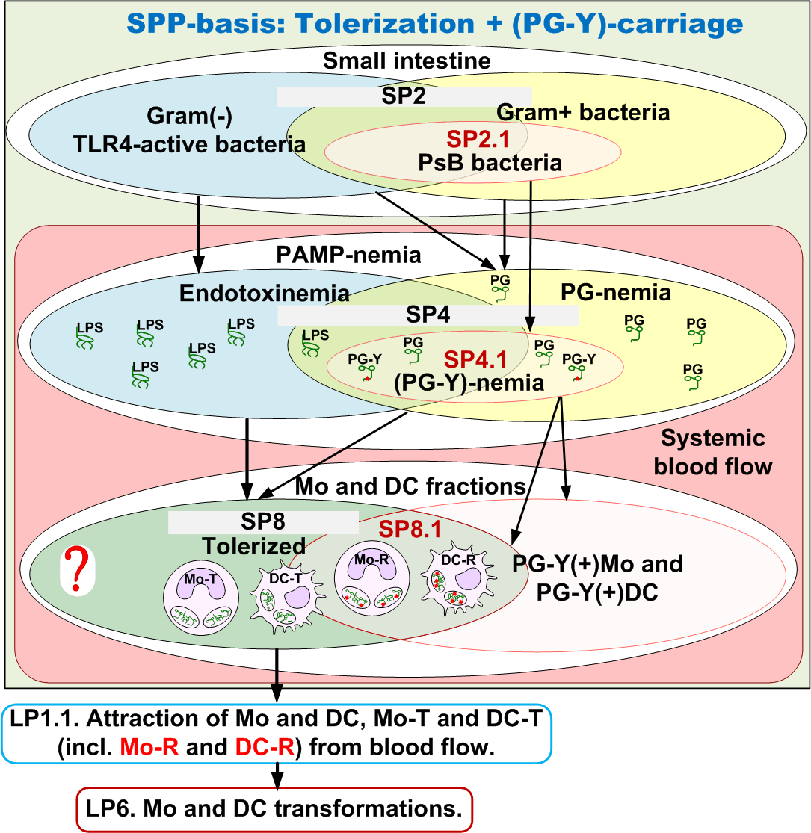

TLR4 is a membranous receptor - ligand to LPS.

Endotoxinemia is the chronic increasing of LPS-load on blood phagocytes resulting in
a) formation of essential share of tolerized phagocytes;
b) increased LPS-carriage of tolerized phagocytes;
c) LPS-level increasing in blood;

PG-nemia is the chronic increasing of PG-load on blood phagocytes resulting in
a) formation of essential share of tolerized phagocytes
(as a rule when coexist with LPS-load only);
b) increased PG-carriage of tolerized phagocytes;
c) PG-level increasing in blood;

(PG-Y)-nemia is the chronic increasing of (PG-Y)-load on blood phagocytes resulting in
a) formation of essential share of tolerized phagocytes
(as a rule when coexist with LPS-load only);
b) increased (PG-Y)-carriage of tolerized phagocytes;
c) (PG-Y)-level increasing in blood;

PAMP-nemia is the chronic increasing of kPAMP-load on blood phagocytes resulting in
a) formation of essential share of tolerized phagocytes;
b) increased kPAMP-carriage of tolerized phagocytes;
c) kPAMP-level increasing in blood;
At SPP kPAMP are LPS and PG.

The SPP-basis is made by three obligatory subprocesses SP2, SP4 and SP8.

Without any of them SPP will be incomplete.
The SPP-basis can be parted on two components: tolerization of phagocytes and (PG-Y)-carriage of phagocytes.

Tolerization of phagocytes assumes growth in small intestine of bacterial populations without PsB (SP2 without SP2.1).
As a result PAMP-nemia without participation of PG-Y takes place (SP4 without SP4.1).
Growth of fractions Mo-T and DC-T in blood flow will be a consequence of joint LPS-load and PG-load on blood phagocytes (SP8 without SP8.1).

And the main contribution is done, as a rule, by LPS-load.

(PG-Y)-carriage of phagocytes assumes growth on small intestine mucous of PsB populations only (SP2.1).
Thus arises (PG-Y)-nemia (SP4.1) and in blood flow there are fractions PG-Y(+)Mo and
PG-Y(+)DC.
But (PG-Y)-load is not enough for occurrence of fractions Mo-T and DC-T as activating (tolerizing) abilities of PG are essentially lower, than such LPS abilities.
Occurrence of tolerized fractions only because of (PG-Y)-load is theoretically possible at essential growth of PsB-populations only (in the absence of any others).
Each of these two components alone, is not enough for occurrence of subfractions Mo-R and
DC-R in blood flow (SP8.1).
Each of components separatly is incomplete SPP-basis (pre-SPP) and can precede development SPP in the concrete patient.

Only their joint action (tolerization and (PG-Y)-carriage of phagocytes) provides growth of subfractions Mo-R and DC-R (SP8.1) – the final subprocess of SPP.
Without subprocess SP8.1 systemic psoriatic process SPP is incomplete and cannot entail start and support of psoriasis.

This figure is based on (Peslyak 2012a, Fig.8, p.64).

(Box 11) Tolerized Mo-T and DC-T

Are lowered
- Secretion of proinflammatory cytokines (TNF-alpha, IL-1beta, IL-12, etc.) after repeated
PAMP-load.
- Expression of HLA-DR, CD74, HLA-DM, CD58 (LFA-3) and CD86 etc.
- Production and level of intracellular proteins cathepsin S and legumain, which are responsible for splitting and processing of antigens
(Wolk 2000, Wolk 2005)
- Production, transport and expression of MHC class II
(Wolk 2003)
- Ability to presentation of antigens and activation of T-lymphocytes.

Raised level of intracellular protein IRAK-M, the general manager of tolerization.

Ability to fast loss of tolerance (to be deprogrammed) under the influence of cytokines-deprogrammers IFN-gamma, GM-CSF and (indirectly) IL-12.

(Adib-Conquy 2009, Cavaillon 2006, Cavaillon 2008, Fitting 2004)

Property 1.
Chemostatuses of Mo-T and DC-T are similar to chemostatuses of nonactivated Mo and DC.
Chemostatus is a range of expressed chemokine receptors.

DC-T – yes
(Turnis 2010),

Mo-T - ?.
(see Box 13)

Changes of chemostatuses of PAMP-tolerized Mo and DC were not investigated until recently.
In work (Turnis 2010) the chemotactic behavior of mouse bone marrow DC after LPS-load of various duration was studied.
Expression CCR7 (and other chemokine receptors) was studied, and also the ability of DC to migrate in lymph nodes.
It is shown that the longer LPS-load lasts, in lesser degree DC expresses CCR7, and the worse their migration goes.
The opposite interrelation between the level of intracellular blocking protein IRAK-M and the level of expression CCR7 is proved.

Property 2. Mo-T and DC-T are kPAMP-carriers.

They have this property because of the lowered level of intracellular proteins which are responsible for degradation of endocytosed content.
(Wolk 2000, Wolk 2005)

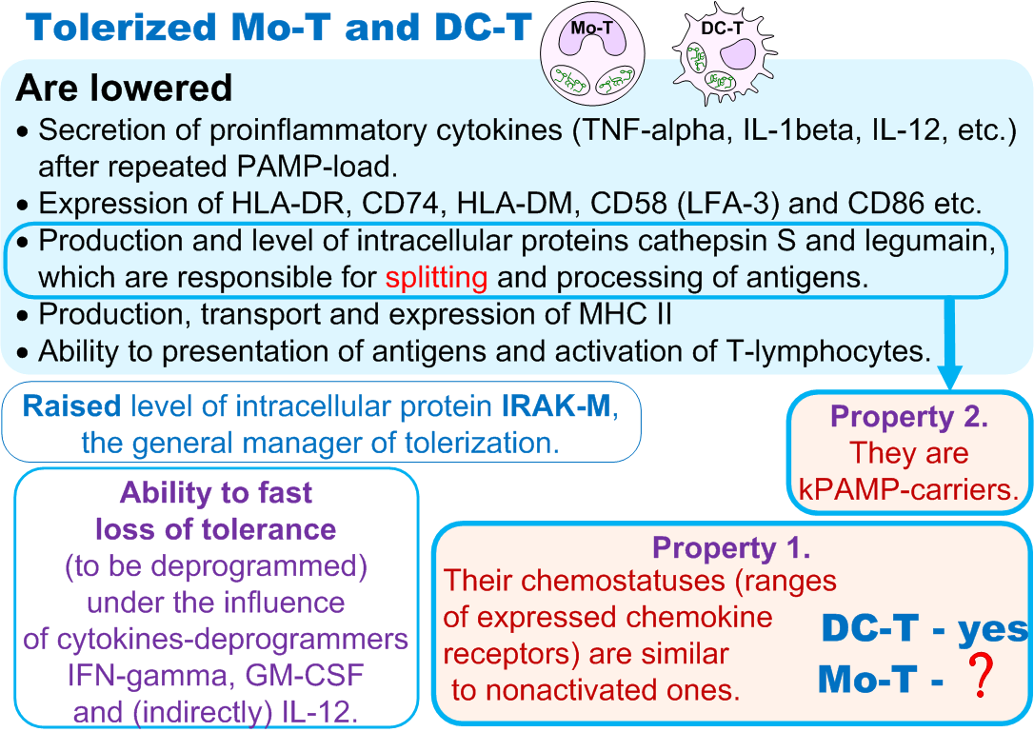

This figure is based on (Peslyak 2012a, p.10 and App.2).

(Box 12) Distribution of stay time of monocytes in blood flow

How tolerized fraction is formed?
Samples of fractionation:
in case of SPP and CARS (Compensatory Anti-inflammatory Response Syndrome).
Is SPP a weak CARS?

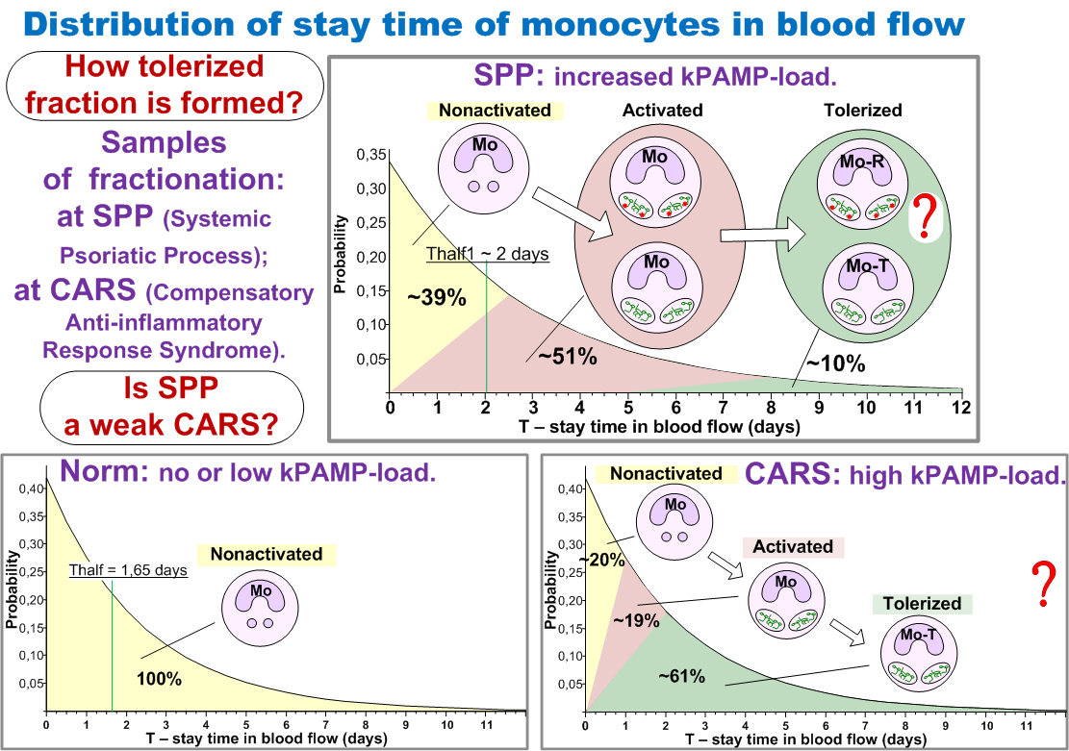

Norm – no or low kPAMP-load
SPP – increased kPAMP-load
CARS – high kPAMP-load

After the exit from the bone marrow monocytes stay in blood flow before they will be involved into tissues or lymph nodes. Leaving from blood flow of certain monocyte occurs in a random way. Exponential distribution takes place for time of stay of monocytes in blood flow

F(T) = LAM*EXP(-LAM*T), where LAM = ln(2)/Thalf

Calculations and estimations of different authors for Thalf - time of half-life of monocytes in human blood flow are resulted in (Peslyak 2012a, App.10, Tab. 7).
T is a stay time in blood flow (horizontal axis), probability (vertical axis);

In norm Thalf is estimated as 1,65 days, at serious psoriasis Thalf is estimated as 2 days
(Peslyak 2012a, p.52).

Total kPAMP-load on certain monocyte is directly proportional to time of its stay in blood flow. Staying in blood flow under chronic kPAMP-load the certain monocyte at first is activated, and then if yet has not left blood flow, is tolerized.
It is possible to assume that at chronic kPAMP-load
(a) in blood flow three fractions of monocytes coexist:
nonactivated, activated and tolerized.
(b) at SPP activated fraction is the biggest.
Assumptions (a) and (b) allow to compound the facts about activated blood Mo at psoriasis (Bevelacqua 2006, Mizutani 1997, Teranishi 1995) and hypothesis about existence
of tolerized Mo-T (SP8).

Nonactivated fraction basically consists of monocytes which have recently left bone marrow. These are monocytes of short-term stay (yellow zone).
Activated fraction consists of monocytes of intermediate-term stay and constantly replenishes with monocytes from nonactivated fraction. Nonactivated monocytes during the first events of essential kPAMP-load (contacts, linkage, endocytosis) become activated (pink zone).
Tolerized fraction consists of monocytes of long-term stay and constantly replenishes with monocytes from activated fraction. Activated monocytes after the long increased kPAMP-load become tolerized (green zone). It occurs at achievement IRAK-M of blocking level.

Sample of such distribution at SPP is represented on top diagram.
Conditionally it is supposed that level of increased kPAMP-load is such, that monocytes which have stayed in blood flow more than 2,5 days, become activated.
Transition from nonactivated condition (yellow zone) to activated (pink zone) occurs gradually. Also conditionally it is supposed that for all monocytes the period of stay in blood flow from 5 till 8 days is transitive from the activated condition (pink zone) to tolerized (green zone).
The areas of each of three zones correspond to share of each fraction:
nonactivated (~39%), activated (~51%) and tolerized (~10%).

The chronic increased PAMP-load (SP4) lays constant impact on blood immune system and includes chronic proinflammatory and anti-inflammatory (in particular SP8) mechanisms.
The result of it is the dynamic equilibrium condition of blood immune system.
It is possible to draw an analogy with the interaction between SIRS (systemic inflammatory response syndrome) and CARS (compensatory anti-inflammatory response syndrome) which take place for more serious reasons than SP4.
Tolerization (reprogramming) monocytes and dendritic cells (SP8) is limited by the compartment of systemic blood flow (and probably bone marrow) and corresponds to the definition of CARS
(Adib-Conquy 2009, Cavaillon 2008).

Sample of such distribution at CARS is represented on bottom right diagram.
Conditionally it is supposed that level of high kPAMP-load is such, that monocytes which have stayed in blood flow more than 1 day, become activated.
Transition from nonactivated condition (yellow zone) to activated (pink zone) occurs gradually. Also conditionally it is supposed that for all monocytes which have stayed in blood flow more than 2 days became tolerized (green zone).
The areas of each of three zones correspond to share of each fraction:
nonactivated (~20%), activated (~19%) and tolerized (~61%).

Is SPP a weak CARS?

This figure is based on (Peslyak 2012a,, App.10, Fig.14 and 15, p.70-71).

(Box 13) CD14+CD16+Mo transformation and chemostatus

In blood flow activated Mo change chemostatus.
Chemokine receptors, which answer for traffic into tissue (CCR1, CCR2, CXCR4), are lowered. CCR7 (main for traffic into lymph node) is increased.
Therefore traffic of activated Mo into tissue is lowered during its activation.

Property 1. Chemostatus of Mo-T is similar to nonactivated.

Inflammation
Cytokines-deprogrammers GM-CSF, IFN-gamma are in abundance.
kPAMP-load is possible.

In inflammatory tissue activated Mo quick transform into MoDC or into MF.
If activated Mo is derived from Mo-R=PG-Y(+)Mo-T it can transform into maDC-Y.

Homeostasis
Cytokines-deprogrammers GM-CSF, IFN-gamma are absent. kPAMP-load is absent.
Tolerized Mo-T slow transform into nonactivated Mo.

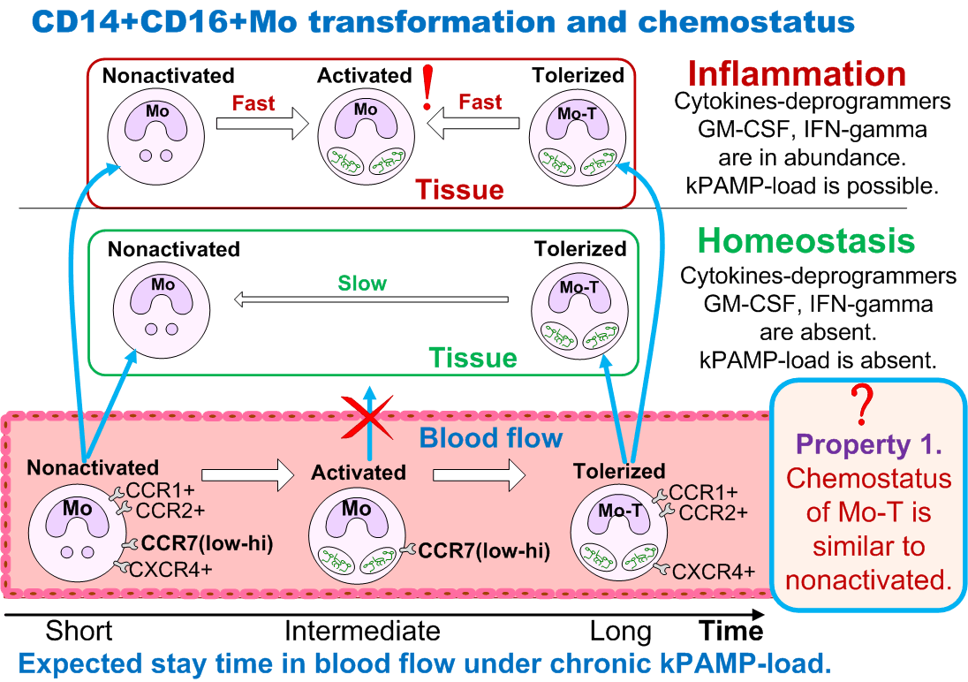

Chemostatus | Range of chemokine receptors expressed by cell (CCR1, CCR2, CCR3 etc.) including the amount of each. Chemostatus of cell defines its behavior in reply to homeostatic and/or inflammatory chemokines.
Cytokines-deprogrammers | Normal phagocytes aren’t tolerized (reprogrammed) and tolerized phagocytes (including R-phagocytes) quickly lose tolerance (deprogrammed) in the presence of such cytokines.  IFN-gamma, GM-CSF and IL-12 are known. IL-12 stimulates non-monocytic cells to produce IFN-gamma.

This figure is based on (Peslyak 2012a, p.10 and App.2).

(Box 14) Wanted!

Offence: Human body damages
Time: During and after damages made by others
Offence area: Skin and joints
Nicknames: Mo-T, DC-T (incl. Mo-R, DC-R)
Residence area: Blood flow of psoriatic persons

Special signs:
Tolerized; kPAMP-carriers;
Raised level of intracellular protein IRAK-M;
(PG-Y)-carriers (Mo-R, DC-R only);

If you can help to find these blood phagocytes call IFPA!

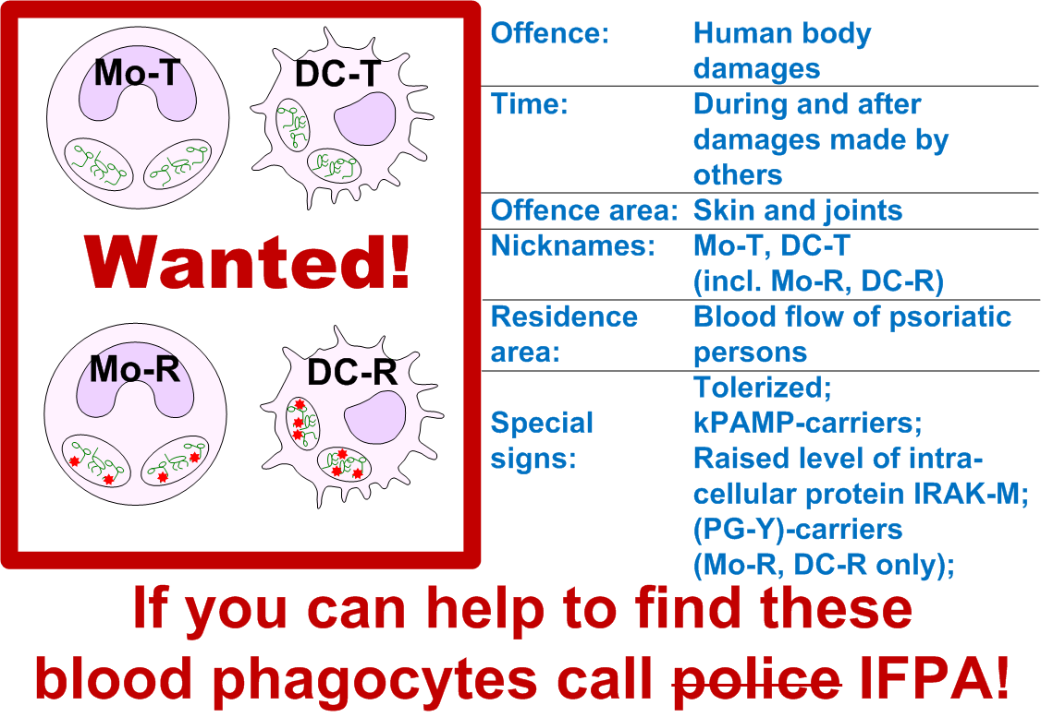

Bibliography
 | Adib-Conquy M, Cavaillon JM. Compensatory anti-inflammatory response syndrome. Thromb Haemost. 2009 Jan;101(1):36-47. 19132187.
 | Amar J, Burcelin R, Ruidavets JB et al. Energy intake is associated with endotoxemia in apparently healthy men. Am J Clin Nutr. 2008 May; 87 (5):1219-23. 18469242.
a. | Baker BS, Laman JD, Powles AV. et al, Peptidoglycan and peptidoglycan-specific Th1 cells in psoriatic skin lesions, J Pathol 2006 Jun;209(2):174-81. 16493599.
b. | Baker BS, Powles A, Fry L. Peptidoglycan: a major aetiological factor for psoriasis? Trends Immunol. 2006 Dec;27(12):545-51. 17045843.
 | Baker BS. Recent Advances in PSORIASIS: The Role of the Immune System. ICP Imperial College Press, 2000, 180 p. ISBN 1860941206.
 | Bevelacqua V, Libra M, Mazzarino MC et al. Long pentraxin 3: a marker of inflammation in untreated psoriatic patients. Int J Mol Med. 2006 Sep;18(3):415-23. 16865225
 | Cavaillon JM, Adib-Conquy M. Bench-to-bedside review: endotoxin tolerance as a model of leukocyte reprogramming in sepsis. Crit Care. 2006;10(5):233. 17044947.
 | Cavaillon JM, Adrie C. Sepsis and Non-infectious Systemic Inflammation: From Biology to Critical Care, Wiley-VCH, 2008, 446 p. ISBN 9783527319350.
 | Fitting C, Dhawan S, Cavaillon JM. Compartmentalization of tolerance to endotoxin. J Infect Dis. 2004 Apr 1;189(7):1295-303. 15031800.
 | Fry L. An Atlas of Psoriasis, Second Edition (Encyclopedia of Visual Medicine Series), Taylor & Francis, 2005, 108 p. ISBN 1842142372.
a. | Fry L, Baker BS, Powles AV. Psoriasis - A possible candidate for vaccination. Autoimmun Rev. 2007 Apr;6(5):286-9. 17412299.
b. | Fry L, Baker BS. Triggering psoriasis: the role of infections and medications. Clin Dermatol. 2007 Nov-Dec;25(6):606-15. 18021899.
. | Garaeva ZS. Clinical significance of levels of antiendotoxic and antibacterial immunity in psoriatics. Dissertation, Kazan, 2005, 142 p. (Rus).
 | Garaeva ZS, Safina NA, Kuklin VT, Bilduk EV, Zinkevich OD. Particular qualities of humoral antibacterial immunity in psoriatics, Kazan Medical Journal, 2001;(5):359-61. (Rus), ISSN 0368-4814. link.
a. | Gumayunova NG. Syndrome of small intestine bacterial overgrowth at psoriatic disease against blastocystic invasion. Dissertation, Chelyabinsk, 2009, 169 p, (Rus), link.
b. | Gumayunova NG, Potaturkina-Nesterova NI, Nesterov AS, Magomedov MA. New approaches to diagnosis intestinal dysbiosis of patients who have psoriatic disease. Bulletin of Russian Peoples Friendship University. Medicine. 2009;(2):93-97. (Rus). elib.
c. | Gumayunova NG. Revealing of small intestine bacterial overgrowth at psoriatic disease. The postgraduate bulletin of the Volga region, 2009 (3-4):162-4. (Rus). elib.
. | Harkov EI, Prohorenkov VI, Shiryaeva YuA. Indices of functional activity of small intestine in patients with psoriasis. Siberian Medical Review, 2008;(6):55-58. (Rus). elib.
. | Harkov EI, Shiryaeva YuA, Teryoshina DS. Malabsoption syndrome and psoriasis: the method of correction. Siberian Medical Journal (Irkutsk), 2006;(7):61-63. (Rus). elib.
. | Harkov EI, Shiryaeva YuA. Malabsorption syndrome in psoriasis: clinical-laboratory parallels. Siberian Medical Review, 2005;(2-3):62-64. (Rus). elib.
 | Mizutani H, Ohmoto Y, Tanaka H, Shimizu M, Psoriatic monocytes respond sensitively to lipopolysaccharide but with limited inflammatory cytokine production, Archives of Dermatological Research, 1997 Oct;289(11):657-9. 9444390
a. | Peslyak MY. Model of pathogenesis of psoriasis. Part 1. Systemic psoriatic process, Moscow, MYPE, 2012, 84 p., ISBN 9785905504020, link.
b. | Peslyak MY. Model of pathogenesis of psoriasis. Part 2. Local processes. Moscow, MYPE, 2012, 110 p., ISBN 9785905504044, link..
 | Teranishi Y, Mizutani H, Murata M, Shimizu M, Matsushima K. Increased spontaneous production of IL-8 in peripheral blood monocytes from the psoriatic patient: relation to focal infection and response to treatments. J Dermatol Sci. 1995 Jul;10(1):8-15. 7577839.
 | Turnis ME, Song XT, Bear A. et al. IRAK-M Removal Counteracts Dendritic Cell Vaccine Deficits in Migration and Longevity. J Immunol. Epub 2010 Sep 3. 20817880.
 | Wolk K, Docke WD, von Baehr V, Volk HD, Sabat R. Impaired antigen presentation by human monocytes during endotoxin tolerance. Blood. 2000 Jul 1;96(1):218-23. 10891454.
 | Wolk K, Grutz G, Witte K, Volk HD, Sabat R. The expression of legumain, an asparaginyl endopeptidase that controls antigen processing, is reduced in endotoxin-tolerant monocytes. Genes Immun. 2005 Aug;6(5):452-6. 15875056.
 | Wolk K, Kunz S, Crompton NE, Volk HD, Sabat R. Multiple mechanisms of reduced major histocompatibility complex class II expression in endotoxin tolerance. J Biol Chem. 2003 May 16;278(20):18030-6. 12637533.

